*FORM VALIDATION*

*UI/UX Design Fundamentals*

*INSTRUCTOR NAME: DHIRAJ J*

*INSTITUTION NAME: CHRIST UNIVERSITY*

*CIA-3*

|  |  |  |
| --- | --- | --- |
| NAMES | REGISTRATION NUMBER | CHRIST EMAIL ID |
| BARATH C G | 2462507 | barath.cg@btech.christuniversity.in |
| RISHI RENJITH | 2461025 | rishi.renjith@btech.christuniversity.in |
| SRI RAMANARAYANA | 2461029 | sri.ramanarayana@btech.christuniversity.in |

📃 ***Abstract:***

This project demonstrates the development of a client-side form validation system using HTML, CSS, Bootstrap, and JavaScript. The form consists of text, email, and password inputs with validation rules to ensure correct and complete data entry. Validation checks for required fields, proper email format, and strong password creation. Error messages are displayed dynamically to guide users, thereby improving the usability and user experience.

🎯 ***Objectives:***

* To design a responsive and visually clean form interface.
* To apply **JavaScript validation** for name, email, and password inputs.
* To display error messages dynamically for invalid inputs.
* To enhance UX by providing immediate feedback.
* To integrate **Bootstrap styling** for form layout and responsiveness.

📌 ***Scope of the Project:***

* Only client-side validation (no backend integration).
* Works across desktop and mobile devices.
* Validation applied only to text, email, and password fields.
* Focus on **usability and front-end user interaction**.

🛠 ***Tools & Technologies Used:***

| **Tool/Technology** | **Purpose** |
| --- | --- |
| **HTML5** | Structure of the form |
| **CSS3** | Custom styling and error highlighting |
| **Bootstrap 5** | Form responsiveness and UI design |
| **JavaScript** | Input validation logic |
| **VS Code** | Code editor |
| **Chrome DevTools** | Debugging and testing |

🧱 ***HTML Structure Overview:***

* Semantic elements <main> and <section> used.
* Bootstrap’s **grid system** for alignment and spacing.
* Dedicated <div> containers below inputs for error messages.

🎨 ***CSS Styling Strategy:***

* Bootstrap utility classes (form-control, mb-3, btn-primary).
* Custom CSS for **error text color** and font size.
* Responsive spacing adjustments for mobile screens.

🎀 ***Bootstrap Overview***

* Used form-control, container, row, col for clean structure.
* btn btn-primary w-100 for a responsive button.
* Utility classes ensured **mobile-friendly** and consistent design.

⚡ ***JavaScript Overview***

* **Validation checks**:
  + Empty fields (required)
  + Email format via regex
  + Password strength (min length, uppercase, number)
* Error messages inserted dynamically using innerText.
* On successful validation → shows **success alert** and resets the form.

🔑 ***Key Features:***

| **Feature** | **Description** |
| --- | --- |
| **Input Validation** | Checks for empty fields, email format, and strong password |
| **Error Messages** | Displayed immediately under invalid fields |
| **Bootstrap Layout** | Clean, structured, responsive form |
| **Responsive Design** | Works seamlessly on desktop and mobile |

⚔️ ***Challenges Faced & Solutions:***

| **Challenge** | **Solution** |
| --- | --- |
| Regex failing for some emails | Used a standard regex for validation |
| Password too weak | Added uppercase + number + min 8 chars rule |
| Error messages overlapping | Added dedicated <div> elements for errors |

✅ ***Outcome:***

* Built a **working form validation system** with Bootstrap design.
* Users receive **real-time feedback** on invalid entries.
* Strengthened understanding of **JavaScript form validation**.
* Gained experience in combining **UI/UX principles** with **functionality**.

📈 ***Future Enhancements:***

* Add a **password strength meter** (symbols, color indicators).
* Store submitted data in a **backend database**.
* Redirect users to a **success page** after submission.
* Improve **accessibility** with ARIA roles and screen reader support.

***CODE:***

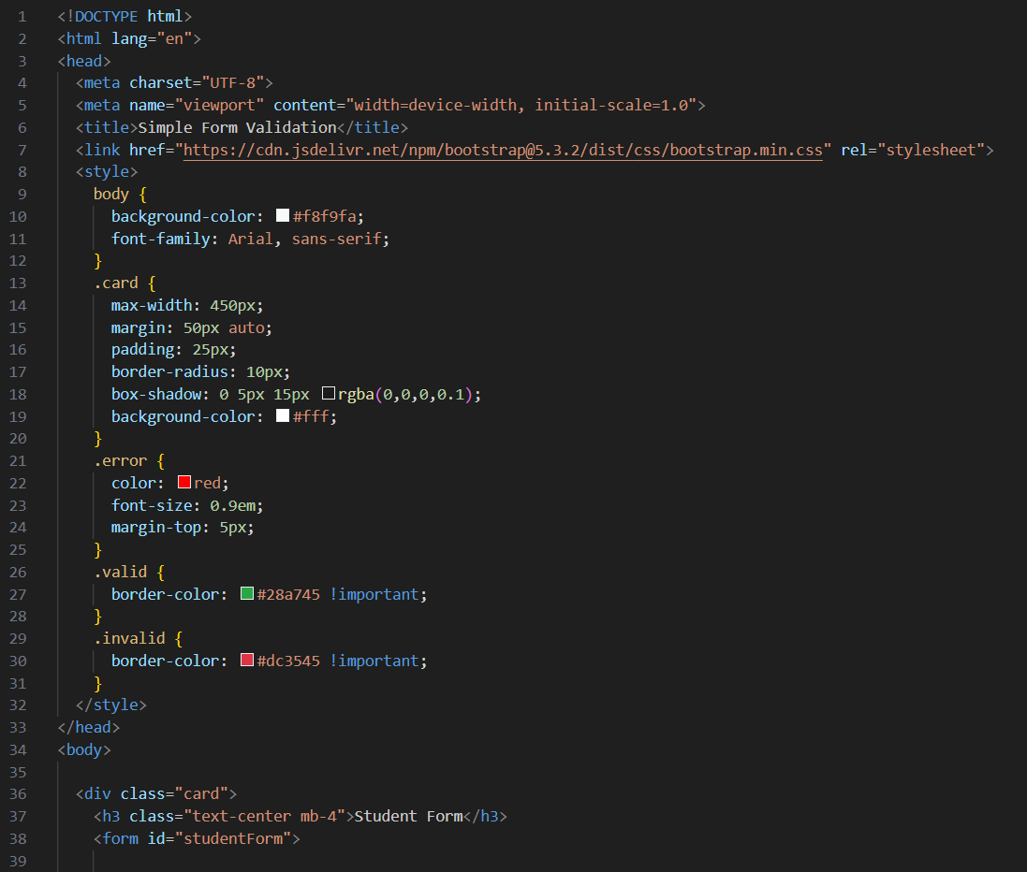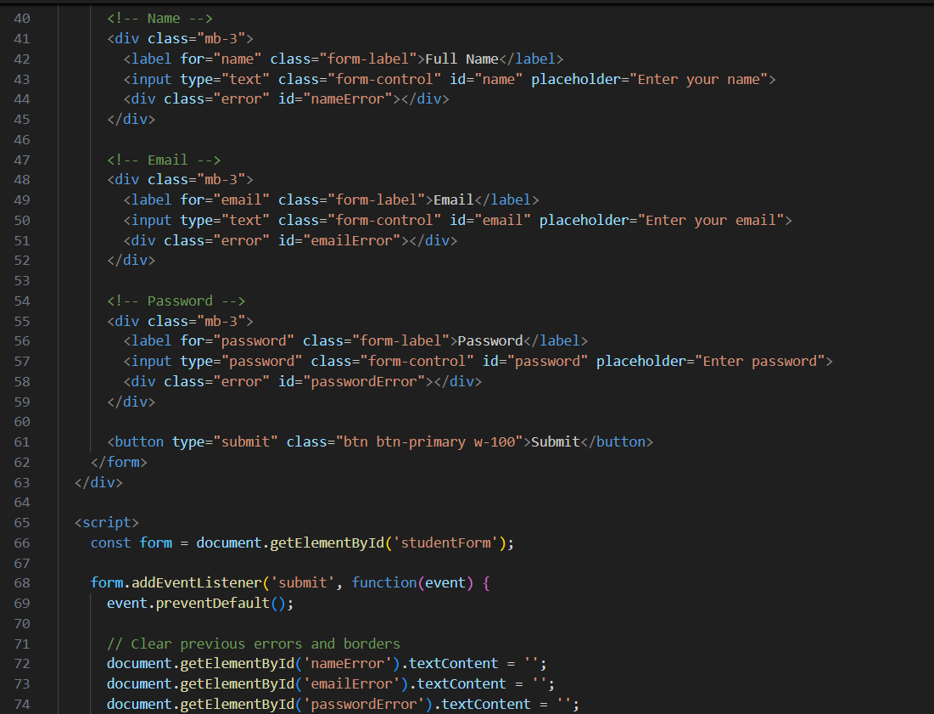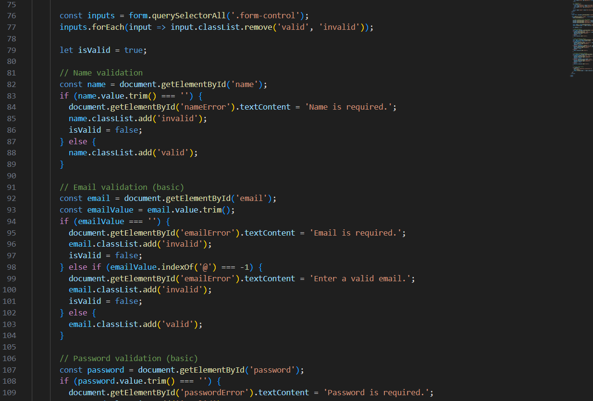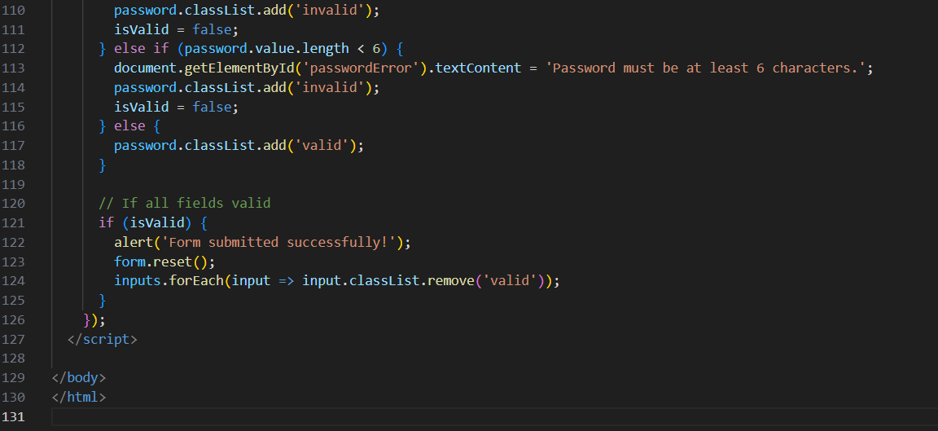

***OUTPUT:***

IF any Error occurs :

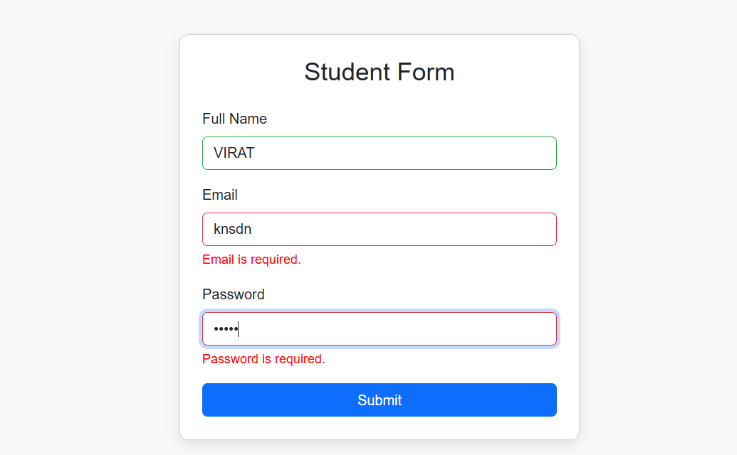

If no Error occurs:

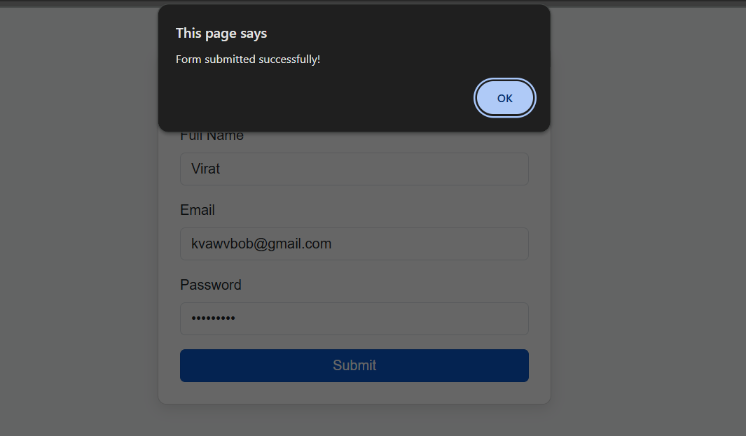

🔚 ***Conclusion:***This Form Validation project shows how front-end technologies (HTML, CSS, Bootstrap, JavaScript) can be integrated to build responsive and user-friendly web forms. The validation ensures accurate input, while Bootstrap enhances the visual design and responsiveness. The project deepened our knowledge of UX design, form handling, and client-side scripting.

📚 ***References:***

* MDN Web Docs: <https://developer.mozilla.org/>
* Bootstrap Documentation: <https://getbootstrap.com/docs/5.3/>
* W3Schools: <https://www.w3schools.com/>
* JavaScript.info: <https://javascript.info/>
* FreeCodeCamp: <https://www.freecodecamp.org/>